SUBCOURSE EDITION
AV0603 C

US ARMY AVIATION CENTER


AIRWAYS CODE AVIATION WEATHER
REPORT AND METEOROLOGICAL
TERMINAL AVIATION REPORT
(METAR) CODE

THIS SUBCOURSE HAS BEEN REVIEWED FOR
OPERATIONS SECURITY CONSIDERATIONS.



AIRWAYS CODE AVIATION WEATHER REPORT AND METEOROLOGICAL
TERMINAL AVIATION REPORT (METAR) CODE

Subcourse Number AV0603

EDITION C

United States Army Aviation Center
Fort Rucker, Alabama 36362-5000

6 Credit Hours

Edition Date: September 1993

SUBCOURSE OVERVIEW

This correspondence course reflects how to identify aviation weather reports and how to decode all information contained in each type.

No prerequisites exist for this subcourse.

This subcourse reflects the current doctrine when it was prepared. In your own work, always refer to the latest publications.

Unless otherwise stated, the masculine gender of singular pronouns refers to men and women.

NOTE: Airways aviation weather reports and METARS have only one space between each entry in a collective; however, for easier reading in this subcourse, spacing has been increased in some reports to accommodate those collectives containing fractions.

TERMINAL LEARNING OBJECTIVE

ACTION: You will identify the types of aviation weather reports and decode all information contained in each.

CONDITION: You will use the material in this correspondence course.

STANDARD: To prove competency of this task, you must achieve a minimum of 70 percent on the examination.

AV0603

TABLE OF CONTENTS

Section Page

Lesson 1: AIRWAYS CODE AVIATION WEATHER REPORT 1

(Programmed Text) Frame

General Information 3
Location Identifier 8 17
Type of Observation 9 19
Review 11 23
Sky Condition and Ceiling 15 31
Obscuration 28 14
Review 35 28
Ceilings 36 30
Review 41 40
Visibility 44 3
Review 50 15
Precipitation 51 17
Sea Level Pressure 58 31
Review 60 35
Surface Temperature and Dew Point 62 39
Wind Direction and Speed 64 43
Altimeter Setting 69 10
Remarks Section 71 14

Practice Exercise 49

Answer Key and Feedback 53

Lesson 2: METEOROLOGICAL TERMINAL AVIATION REPORT 57

(Programmed Text) Frame

General Information 1 59
Location Identifier 3 63
Wind Direction and Speed 5 67
Visibility 10 64
Runway Visual Range 11 66
Present Weather 12 68
Review 13 70
Cloud Group 15 59
Temperature and Dew Point 24 64
Altimeter Setting 25 66

i AV0603

Section Frame Page

Ceiling 26 68
Remarks 27 70

Practice Exercise 75

Answer Key and Feedback 77

Appendix: EXHIBITS 81

ii AV0603

LESSON 1

AIRWAYS CODE AVIATION WEATHER REPORT

Critical Task: 011-144-0010

OVERVIEW

LESSON DESCRIPTION:

In this lesson you will learn to decode the airways code aviation weather report to include reporting station, type of report, time, sky and ceiling, visibility, weather phenomena and obstructions to vision, sea level pressure, temperature and dew point, wind direction and speed, altimeter setting, runway visual range (RVR) when it is available, and remarks.

TERMINAL LEARNING OBJECTIVE:

ACTION: Interpret airways code aviation weather reports.

CONDITION: You will use the lesson text to complete the action.

STANDARD: You will decode each item of information on an airways code aviation weather report.

REFERENCE: The material in this lesson was derived from the following publications: DOD FLIP, GP; FAA Order 7350.5; FM 1-230; and International Civil Aviation Organization (ICAO) Document 7910.

SAFETY CONSIDERATIONS: none

TRAINING RISK ASSESSMENT CODE: L

ENVIRONMENTAL CONSIDERATIONS: none

INTRODUCTION

Aviation circuits give the fastest way of collecting and relaying existing weather condition information over a wide area. These circuits also are used for checking weather trends, changing and verifying forecasts, and adding information that is not reported as often. The frequency of aviation weather reports makes them useful tools for the aviator and forecaster. In your duties as an aviation operations specialist, you may see airways code aviation weather reports and METARS on a daily basis. Therefore, you

1 AV0603
must understand and be able to interpret (explain) the information found in these reports. The purpose of this subcourse is to teach you how to identify the types of aviation weather reports and how to decode all information contained in each report.

THE PROGRAMMED TEXT (PT) THAT FOLLOWS CONTAINS 86 FRAMES. THIS PT WILL HELP YOU UNDERSTAND THE DIFFERENT PORTIONS OF THE AIRWAYS CODE AVIATION WEATHER REPORT. WRITE OR CIRCLE THE ANSWER TO EACH QUESTION WITHIN EACH FRAME, AND CHECK YOUR ANSWER WITH THE SOLUTION AT THE TOP OF THE NEXT FRAME.

BEFORE YOU BEGIN, REMOVE THE EXHIBITS AT THE BACK OF THIS SUBCOURSE (PAGES 87 THROUGH 101). BEGIN WITH FRAME 1 ON PAGE 3 AND CONTINUE WITH THE FRAMES AT THE TOP OF THE RIGHT-HAND (ODD-NUMBERED) PAGES UNTIL GIVEN FURTHER INSTRUCTIONS.

2 AV0603

GENERAL INFORMATION FRAME 1

If you think about all the factors that cause irregular operations in scheduled military flights, you will probably find that weather presents the most problems. Therefore, it is necessary that current ________________ information be available to those personnel who dispatch or fly military aircraft.

*********************************************************************
VISIBILITY FRAME 44

The third part of the weather report contains the surface horizontal visibility that is reported by the location.

NOTE: One space is left between the sky condition or ceiling entry and the visibility entry.

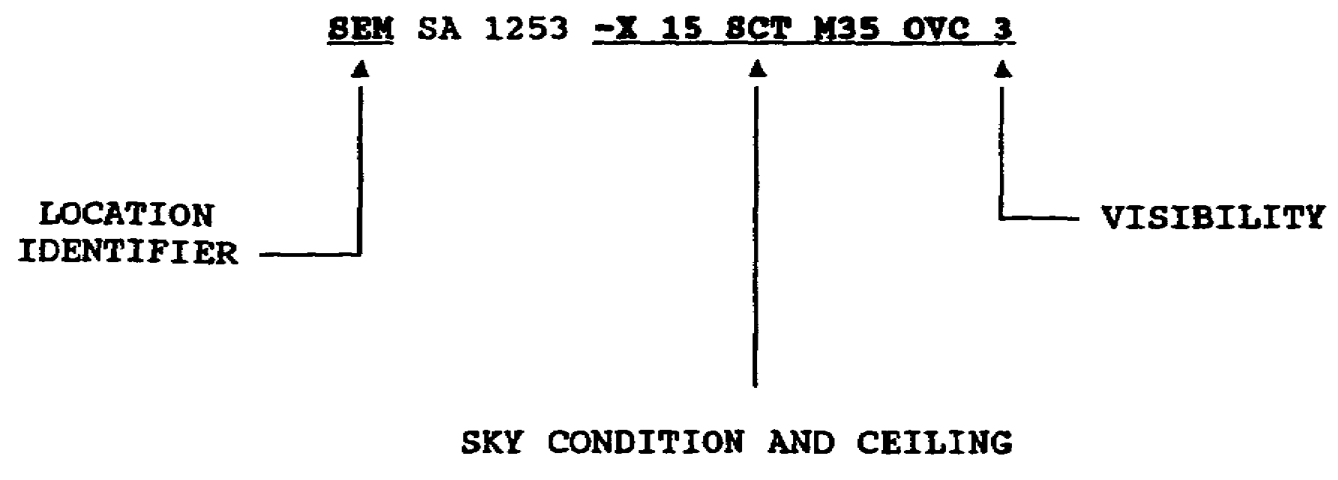

3 AV0603

FRAME 23

All visible clouds are reported in ascending (increasing) order. The amount of clouds in each layer (cumulative from the surface upward) is reported by using the appropriate abbreviation.

*********************************************************************

FRAME 66

When the wind is gusty, the letter "G" is added after the average wind speed and is followed by the peak (highest) speed of the gust. Gusts are sudden, intermittent (now and then) increases in wind speed of 10 knots or more above the average wind speed.



In the following report, the wind direction is from __________ degrees, the average wind speed is_________ knots, and the peak speed of the gust is _________ knots.

LSF SA 1552 1Ø SCT M25 OVC 3R 17Ø/34/3Ø/1912G25/ØØl

4 AV0603

ANSWER 1

weather
---------------------------------------------------------------------
FRAME 2

Observers assemble (put together) surface weather observation information hourly throughout the United States. This information, transmitted (sent) over teletype or computer circuits in coded form, is called an airways code aviation weather report (Exhibit 1).

*********************************************************************
ANSWER 44

No response required.

---------------------------------------------------------------------
FRAME 45

The visibility is reported in statute miles and in increments (amounts) as shown below.

Visibility less than 3 miles--fraction included
Visibility 3 to 15 miles--nearest mile
Visibility over 15 miles--nearest 5 miles

In the report below, Lawson Army Airfield (AAF)(LSF) is reporting a visibility of__________ mile.

LSF SA 1153 -X 8 -BKN E18 OVC 7/8 H

5 AV0603

ANSWER 23

No response required.
---------------------------------------------------------------------
FRAME 24

The height of the scattered layer below is _________feet AGL, the broken layer is ________feet AGL, and the overcast is_________ feet AGL. (Remember that clouds are measured by their bases, or the lowest portion of the clouds as shown in the diagram below.)

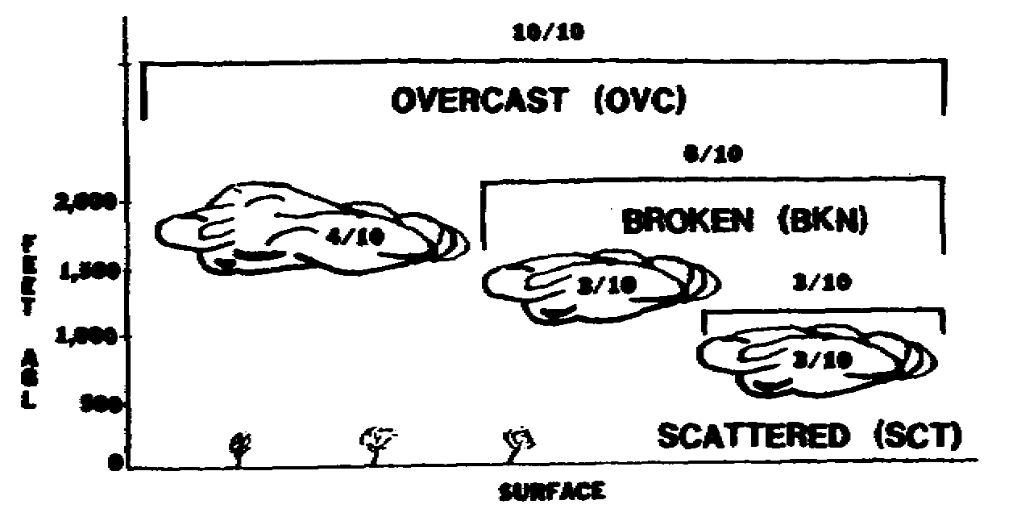

*********************************************************************
ANSWER 66

190, 12, 25
---------------------------------------------------------------------
FRAME 67

A squall is defined as a sudden increase in wind speed of at least 15 knots to a sustained speed of 20 knots or more lasting for at least one minute. The letter "Q" is added after the average wind speed and is followed by the peak speed of the squall.

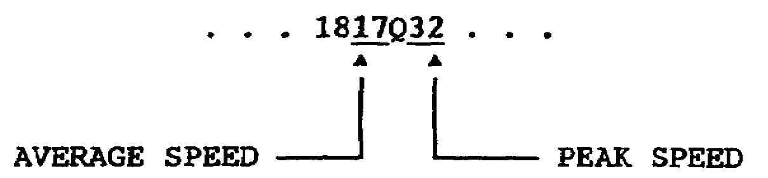

In the following report, the wind direction is________ degrees, the average wind speed is ________knots, and the peak speed of the squall is________ knots.

BHM SP Ø431 E18 OVC 3TRW 132/82/76/Ø515Q32/992

6 AV0603

ANSWER 2

No response required.
---------------------------------------------------------------------
FRAME 3

Below is an example of a heading in an airways aviation weather report.

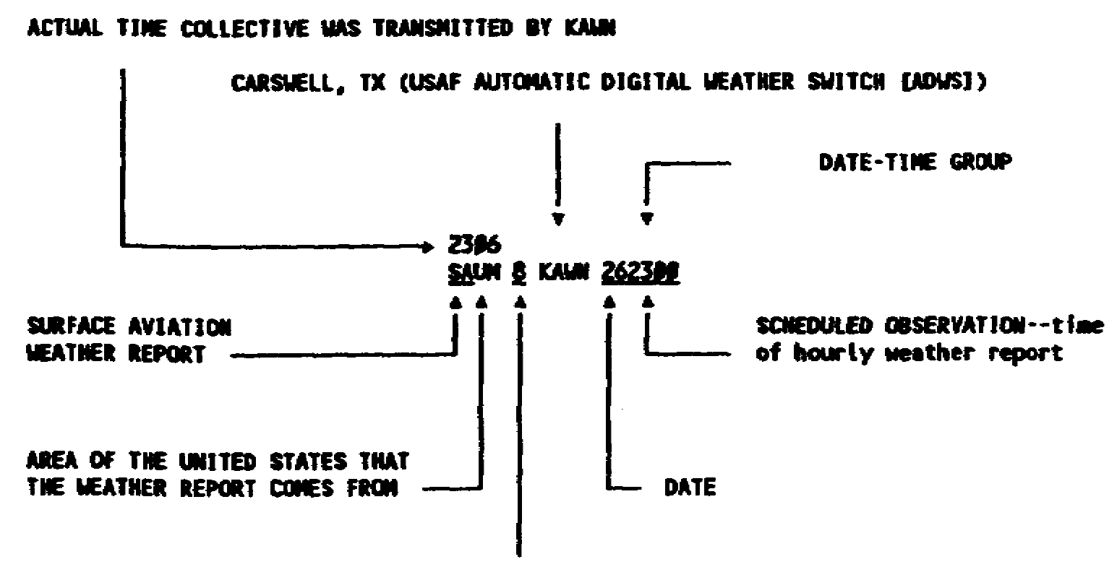
NUMBER INDICATING A SECTION OF MIDDLE US. The sections are numbered from 1 at the Canadian border to 8 at the Gulf of Mexico. These numbers are used by the National Weather Service (NWS) civilian observers. Air Weather Service military areas place a numeral 6 in front of the number (61 to 68).
*********************************************************************
ANSWER 45

7/8
---------------------------------------------------------------------
FRAME 46

What is the ceiling and visibility at the following locations?

ATL SA 1845 12 -BKN M25 OVC 4 R
CEW SA 1853 W5 X 3/4 F
CSG SA 1851 25 SCT 35-BKN 1/2 GF

VISIBILITY
CEILING IN MILES
ATL = ________________________ _______

CEW = ________________________ _______

CSG = ________________________ _______

7 AV0603
ANSWER 24

500, 1,000, 1,500
---------------------------------------------------------------------
FRAME 25

In the diagram below, the first layer above the ground is reported as ___________________, the second layer will be reported as __________, and the third layer will be reported as___________________.

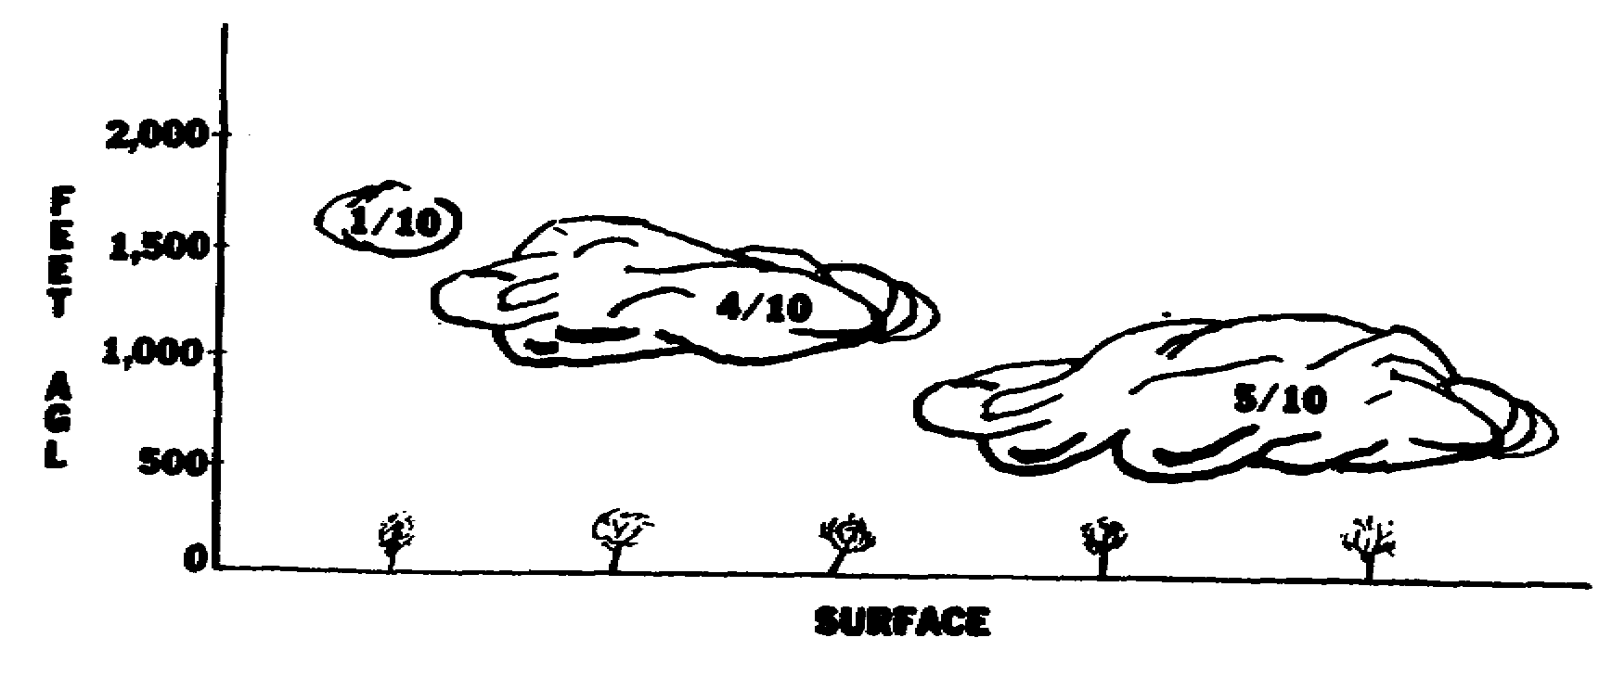

*********************************************************************
ANSWER 67

050, 15, 32
---------------------------------------------------------------------
FRAME 68

STUDY: Exhibit 8

A pilot is flying at 1,500 feet above the surface on a heading of 360 degrees. Circle the location over which he would have the most direct head wind.

LSF SA 1152 CLR 15 177/85/62/18Ø5/ØØ3
OZR SA 1148 M25 OVC 1Ø 146/73/53/3612/995
SEM SA 115Ø -X 8 SCT 25 -BKN E3Ø OVC 3L-F 227/59/56/ØØØØ/Ø16

8 AV0603

ANSWER 3

No response required.
---------------------------------------------------------------------
FRAME 4

There are two times listed in the heading of an airways aviation weather report. One is the actual time the collective report is transmitted by KAWN. The other is the scheduled hourly record observation time. The actual observation time immediately follows the type of report.

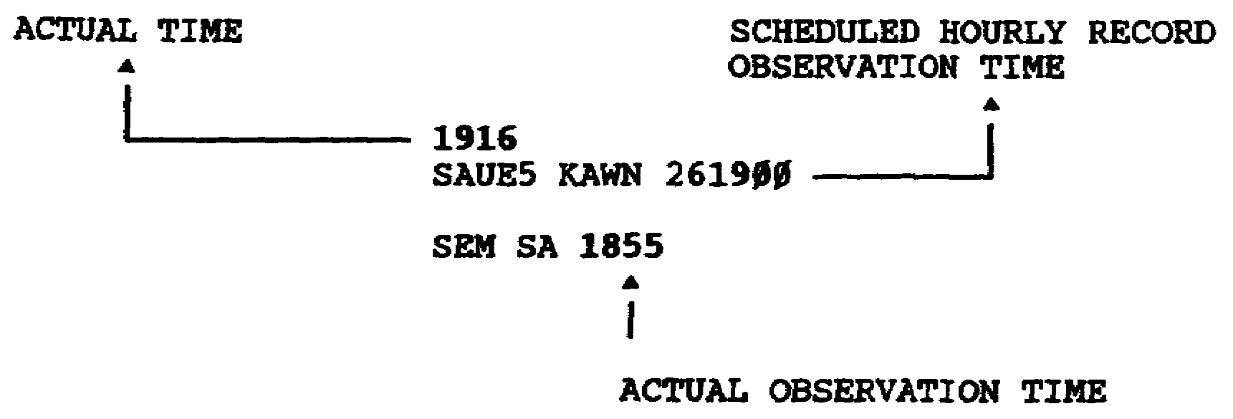

*********************************************************************
ANSWER 46

ATL = measured, 2,500 overcast; 4
CEW = indefinite, 500 obscured; 3/4
CSG = no ceiling reported; 1/2

---------------------------------------------------------------------
FRAME 47

What is the ceiling and visibility at the following locations?

MGM SA 1952 M18 OVC 2 1/2 H
OZR SA 1949 E25 BKN 7

VISIBILITY
CEILING IN MILES

MGM = _______________________ _______

OZR = _______________________ _______

9 AV0603

ANSWER 25

scattered, broken, overcast.
---------------------------------------------------------------------
FRAME 26

The height of the cloud base is reported in hundreds of feet above the surface. The figure representing the height is placed before the sky condition symbol. The last two digits are left off. If a scattered layer of clouds is 800 feet above the surface, it would be reported as 8 SCT. A broken layer of clouds at 1,500 feet would be reported as 15 BKN.

*********************************************************************
ANSWER 68

OZR (The pilot is flying toward 360 degrees, and the wind is from 360 degrees at 12 knots.)

---------------------------------------------------------------------
ALTIMETER SETTING FRAME 69

The altimeter setting is the next part of the report and is separated from the wind by a slant line. The altimeter setting is always reported in three-digit numbers and is interpreted much in the same way as you did the sea level pressure earlier. You must mark off two decimal points and then add a numeral 2 or 3 (whichever will make the complete figure read nearer to 29.92 inches of mercury [" Hg] which is the standard pressure) in front of the figure.

In the following report, the altimeter setting is__________” Hg.

MOB SA 1754 CLR 15 2Ø2/63/47/18Ø5/Ø12

ALTIMETER SETTING

10 AV0603

ANSWER 4

No response required.
---------------------------------------------------------------------
FRAME 5

STUDY: Exhibit 3

Weather stations are divided into three areas in the United States: Western (W), Middle (M), and Eastern (E). These are identified in an hourly weather report as UW, UM, or UE. The U stands for United States.

*********************************************************************
ANSWER 47

a. measured, 1,800 overcast; 2 1/2
b. estimated, 2,500 broken; 7
---------------------------------------------------------------------
FRAME 48

The ceiling in an airways code aviation weather report is the lowest sky condition reported as ____________, _____________, or ___________ and is not classified as thin (-) or partial.

11 AV0603

ANSWER 26

No response required.
---------------------------------------------------------------------
FRAME 27

How would the two layers of clouds shown below be reported?
_________________and____________________.

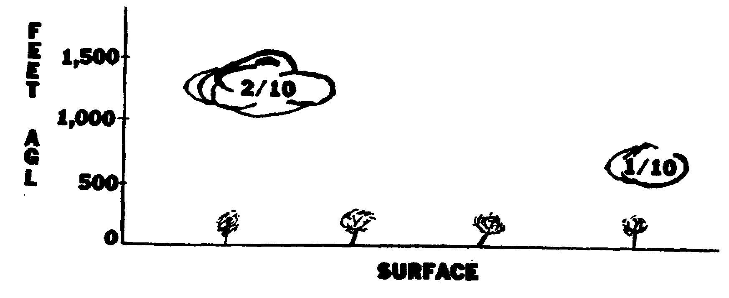
*********************************************************************
ANSWER 69

30.12
---------------------------------------------------------------------
FRAME 70

What is the ceiling, visibility, and altimeter setting at each of the locations below?

LSF SA 1852 W1 X 1/16 F 226/55/55/ØØØØ/Ø16
SEM RS 1849 -X 9 -BKN M15 OVC 1/2 R-F 146/55/52/18Ø8/995

ALTIMETER
CEILING VISIBILITY SETTING

LSF ________________________ ________________ _____

SEM ________________________ ________________ _____

12 AV0603

ANSWER 5

No response required.
---------------------------------------------------------------------
FRAME 6

Aviation weather reports are in Zulu (Z) time. Aviation weather reports will not include the letter "Z" after the four digits (numbers) representing the hours in the date-time group. However, it is always recorded in Zulu time.

*********************************************************************
ANSWER 48

broken, overcast, obscured.
---------------------------------------------------------------------
FRAME 49

Circle the airways code aviation weather report below that matches the sky condition in the diagram?

OZR SA 1253 5 SCT 12 SCT 25 SCT 2H
OZR SA 1249 5 SCT M12 BKN 25 OVC 1 1/2 R
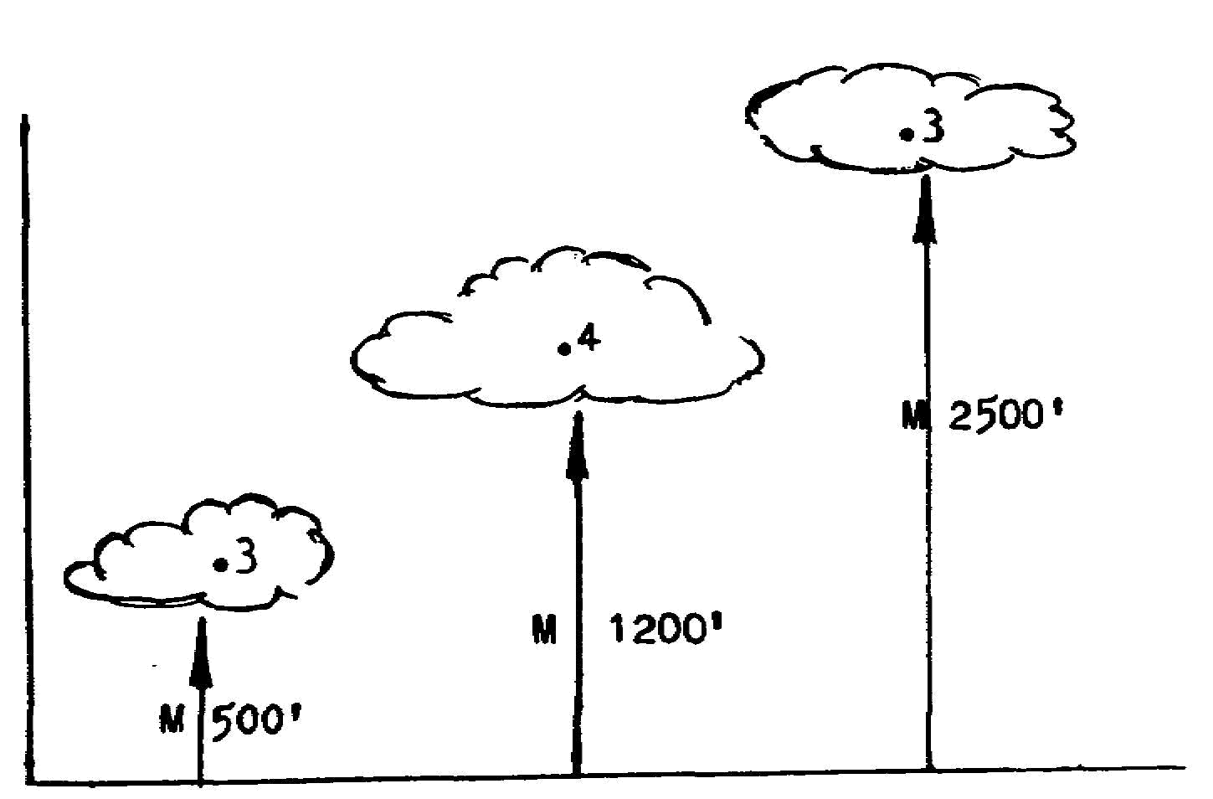

13 AV0603

ANSWER 27

5 SCT, 10 SCT
---------------------------------------------------------------------
OBSCURATION FRAME 28

The abbreviations we have covered represent sky coverage by cloud layer or layers above the surface. There are other conditions that are surface based and are called obscurations.

*********************************************************************

ANSWER 70

a. indefinite 100 obscured, 1/16 mile; 30.16" Hg
b. measured 1,500 overcast; 1/2 mile; 29.95" Hg

---------------------------------------------------------------------
REMARKS SECTION FRAME 71

Immediately following the altimeter setting and separated by a slant line is the remarks section. This section contains information reported by pilots; variable ceilings and visibilities; time that any precipitation began, ended, or both; RVR information; the amount of any partial obscuration; and other important information.

(Refer to Exhibit 9, Item 29.) In the report below, the F4 in the remarks section indicates that there is a partial obscuration obscuring ________of the sky.

OZR SA Ø75Ø -X 1Ø -BKN E25 OVC 1/2 L-F 132/75/73/ØØØØ/992/F4

14 AV0603

ANSWER 6

No response required.
---------------------------------------------------------------------
FRAME 7

The following calculations give you local time:

Eastern Standard Time subtract five hours
Central Standard Time subtract six hours
Mountain Standard Time subtract seven hours
Pacific Standard Time subtract eight hours

EXAMPLE: The time is 1400Z, and you want to know what time it is in Pacific Standard Time.

1400Z
-0800
0600 Pacific Standard Time

*********************************************************************
ANSWER 49

OZR SA 1249
---------------------------------------------------------------------
REVIEW FRAME 50

The first part of the report is the location identifier; the second part is the type of report; the third part is the actual time of the observation; the fourth part is the sky condition and ceiling; the fifth part is the visibility; the sixth part is for _______________ and______________________.

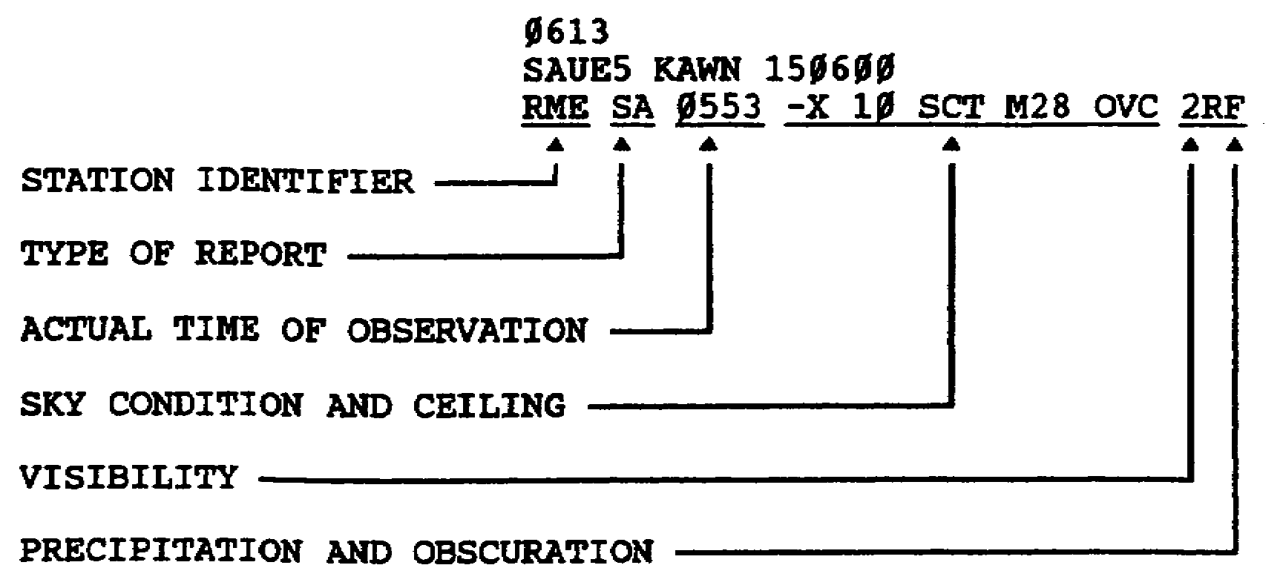

15 AV0603

ANSWER 28

No response required.
---------------------------------------------------------------------
FRAME 29

If fog, haze, smoke, or some other obscuration extends from the surface upward (thus restricting the vertical visibility), we would call it a___________________________________.

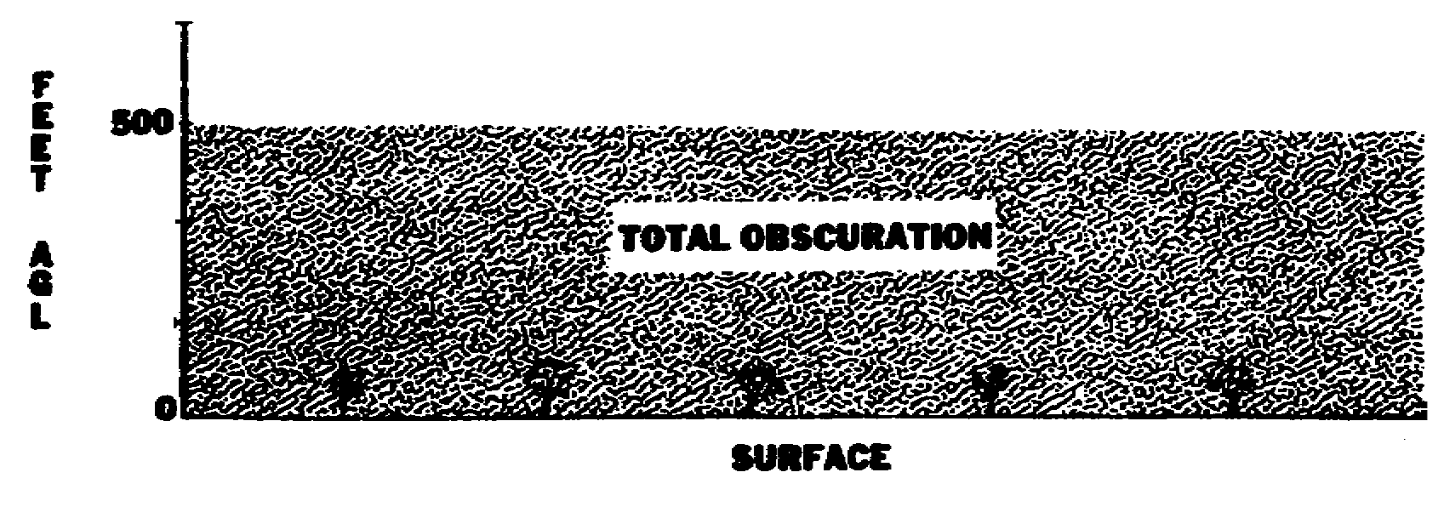
*********************************************************************
ANSWER 71

4/10
---------------------------------------------------------------------
FRAME 72

(Refer to Exhibits 6 and 9.) In the report below, the partial obscuration is caused by___________ and ___________. The condition is obscuring________ of the sky.

LSF SA 2251 -X 9 SCT 12 -BKN M25 OVC 2R-HK 132/64/56/24Ø8/992/HK5

16 AV0603

ANSWER 7

No response required.
---------------------------------------------------------------------
LOCATION IDENTIFIER FRAME 8

Now, let's break down the body of an airways code aviation weather report and study the symbols and letters in each entry. The first part is a three-letter group. This group contains letters that identify the location reporting the information and is called the___________________________.

NOTE: Location identifiers may be decoded by using FAA Order 7350.5.

2311
SAUE5 KAWN 1823ØØ

LIZ
RME

LOCATION IDENTIFIER

*********************************************************************
ANSWER 50

precipitation, obscurations.

---------------------------------------------------------------------
PRECIPITATION FRAME 51

(Refer to Exhibit 5.) When precipitation is falling, it must be reported regardless of the visibility.

17 AV0603

ANSWER 29

total obscuration.
---------------------------------------------------------------------
FRAME 30

An obscuration is reported with the symbol "X" (10/10 of the sky is obscured). When you see this symbol, you know that fog, dust, haze, or smoke is surface based and is restricting the vertical visibility.

*********************************************************************
ANSWER 72

haze, smoke; 5/10
---------------------------------------------------------------------
FRAME 73

0611
SAUM8 KAWN Ø5Ø6ØØ

OZR SA Ø551 -X 15 -BKN E25 OVC 2S 132/25/19/ØØØØ/992/SB25
LSF SA Ø553 5 -BKN M12 OVC 1/2 ZR 132/15/1Ø/36Ø8/992/ZRB37

(Refer to Exhibit 9, Item 2.) The airways code aviation weather report above was scheduled for transmission on the fifth day of the month at 0600Z. At that time, it was snowing. In the remarks section, the entry "SB25" indicates that snow began falling at 25 minutes past the previous hour of the report or that snow began at Ø525Z.

Precipitation begin falling at Lawson AAF (LSF) at________________.

What type precipitation was it?___________________.

18 AV0603

ANSWER 8

location identifier.
---------------------------------------------------------------------
TYPE OF OBSERVATION FRAME 9

(Refer to Exhibits 1 and 2.) There are four types of airways code aviation weather reports: Record (hourly), Record-Special, Special, and Local. The types of observation sent out on teletype or computer circuits include SA, RS, and SP.

a. Record (hourly)(SA) is transmitted (sent) every hour on the hour and is often called an hourly report for this reason.

b. Record-Special (RS) is sent on the hour to indicate a significant change in the weather since the last hourly report.

*********************************************************************
ANSWER 51

No response required.
---------------------------------------------------------------------
FRAME 52

What type precipitation is being reported by the following stations?

NOTE: (See Exhibit 2, code Table 4.) Intensities follow precipitation symbols.

LSF = ______________________

OZR = ______________________

SEM = ______________________

1211
SAUM8 KAWN 1212ØØ

LSF SA 1149 -X 15 SCT M25 OVC 1/2 L
OZR RS 1147 E7 OVC 3/4 RW
SEM SA 1152 8 -BKN E12 OVC 7/8 S

19 AV0603

ANSWER 30

No response required.
---------------------------------------------------------------------
FRAME 31

A broken layer of clouds 300 feet above the surface would be reported as 3 BKN. However, a sky condition of 3 X would indicate that the sky was completely obscured by some surface-based phenomena and that the _____________________________was 300 feet.

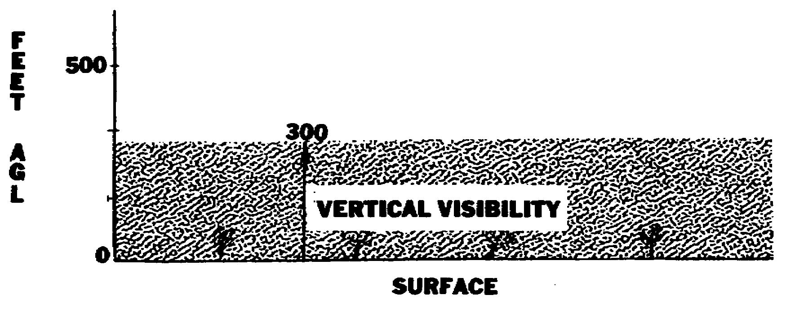

*********************************************************************

ANSWER 73

Ø537Z; freezing rain
---------------------------------------------------------------------
FRAME 74

In the report below, the partial obscuration is caused by________. This condition is obscuring_____________ of the sky. Cairns (OZR) also is reporting rain showers that began at________________.

Ø9Ø8
SAUM8 KAWN 26Ø9ØØ

OZR SA Ø851 -X 8 SCT 12 -BKN E25 OVC 3/4 RWK 132/65/6Ø/
2ØØ9/992/RWB31 K3

20 AV0603

ANSWER 9

No response required.
---------------------------------------------------------------------
FRAME 10

c. Special (SP) is taken and distributed as required to report significant changes in weather conditions between hourly reports.

d. Local reflects changing conditions significant to airfield operations. Locals are, therefore, passed to local agencies only and are not transmitted over the teletype system unless the Local meets the requirements of a Record or Special observation.

*********************************************************************
ANSWER 52

LSF = drizzle
OZR = rain showers
SEM = snow
---------------------------------------------------------------------
FRAME 53
17Ø9
SAUM8 KAWN 2517ØØ
SEM SA 1653 25 SCT E3Ø OVC 2 1/2 ZR

Circle the type precipitation below that Craig AFB (SEM) is reporting?

ice pellets freezing rain rain and snow

21 AV0603

ANSWER 31

vertical visibility
---------------------------------------------------------------------
FRAME 32

When the sun, moon, stars, or higher clouds are visible through a lower cloud layer, a minus sign (-) is placed in front of the sky condition abbreviation to indicate that the cloud layer is thin.

EXAMPLE: The condition below would be reported as 12 -SCT.

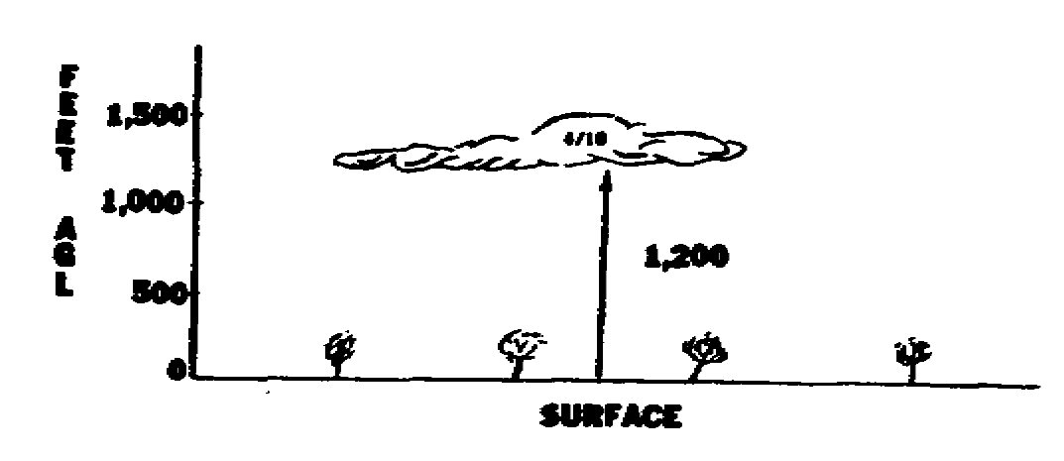

*********************************************************************
ANSWER 74

smoke; 3/10; Ø831Z.
---------------------------------------------------------------------
FRAME 75

(Refer to Exhibit 9, Item 18.) If the ceiling, visibility, or both is reported as variable, it must be explained in the remarks section. In the report below, the letter "V" indicates that the ceiling and visibility are variable.

OZR SA 1646 5 SCT M13V OVC 1VS+ 132/25/15/36Ø8/992/SB25
CIG 12V14 VSBY 1/4 V 1 1/2

In the remarks section for OZR, "VSBY 1/4 V 1 1/2" indicates that the visibility is variable from 1/4 mile to 1 1/2 miles, and "CIG 12V14" indicates that the ceiling is variable from__________ feet to_____ feet.

22 AV0603

ANSWER 10

No response required.
---------------------------------------------------------------------
REVIEW FRAME 11

1. The weather reporting stations in the United States are divided into _____________areas.

2. Military stations in Alabama are in area___________.

*********************************************************************
ANSWER 53

freezing rain
---------------------------------------------------------------------
FRAME 54

STUDY: Exhibit 6

When an obscuration is present, it must be reported when the visibility is reported as 6 miles or less.

What type obscuration is being reported by the following stations?

LSF = ___________
OZR = ___________
SEM = ___________

12Ø7
SAUM8 KAWN Ø912ØØ

LSF RS 115Ø -X M12 BKN 3/4 K
OZR SA 1154 5 SCT 12 -BKN E15 OVC 7/8 F
SEM SA 1152 E12 BKN 15 OVC 3H

23 AV0603

ANSWER 32

No response required.
---------------------------------------------------------------------
FRAME 33

What are the meanings below?

15 -BKN = ____________________________.

8 -SCT = ____________________________.

*********************************************************************
ANSWER 75

1,200, 1,400
---------------------------------------------------------------------
FRAME 76

In the report below, the ceiling is variable from______________ feet to__________ feet. The visibility is variable from_____________ mile to__________ mile.

OZR SA ØØ53 -X M8V OVC 3/4 F 132/34/33/ØØØØ/992/F3 CIG
7V9 VSBY 1/4 V 7/8

24 AV0603

ANSWER 11

1. three
2. UM
---------------------------------------------------------------------
FRAME 12

3. Using the example below, the type of observation is ____________, and the actual time of observation is___________.

2311
SAUE5 KAWN 1823ØØ

L1Z SA 2253
RME

*********************************************************************
ANSWER 54

LSF = smoke
OZR = fog
SEM = haze
---------------------------------------------------------------------
FRAME 55

What types of precipitation and obscuration are being reported by the stations below?

PRECIPITATION OBSCURATION

LIZ _______________________ ___________

RME _______________________ ___________

Ø712
SAUE5 KAWN Ø6Ø7ØØ

LIZ SA Ø653 -X 6 -BKN M18 OVC 3L-F
RME SA Ø651 -X 8 SCT M3Ø OVC 1/2 ZR-H

25 AV0603

ANSWER 33

15 -BKN = 1,500, thin broken
8 -SCT = 800, thin scattered
---------------------------------------------------------------------
FRAME 34

When an obscuration is in patches and hiding part (1/10 or more but less than 10/10) of the sky, it is called a partial obscuration.
This is reported with a -X.

The base of a cloud layer is always above the surface of the earth; however, the base of an obscuration and a partial obscuration is always on the ___________________of the earth.

*********************************************************************
ANSWER 76

700, 900; 1/4, 7/8
---------------------------------------------------------------------
FRAME 77
RVR is the maximum horizontal distance down a specified instrument runway at which a pilot can see and identify standard high intensity runway lights. It is always determined using a transmissometer and is reported in hundreds of feet (drop the last two digits). RVR is reported during periods in which the prevailing visibility is 1 mile or less or the RVR is 6,000 feet or less.

EXAMPLE: R28VR38 would show that on Runway 28 the RVR is 3,800 feet.

(Refer to Exhibit 9, Item 15.) Explain the remarks section of the report below for OZR.

OZR SA Ø249 2Ø SCT M35 OVC 3/4 39/28/2922G32/981/R32VR42

26 AV0603

ANSWER 12

3. SA or Record, 2253

---------------------------------------------------------------------
FRAME 13

4. In the airways code aviation weather report below, the collective was transmitted over the teletype or computer circuits at _________Z.

5. The heading below was transmitted on the________________ day of the current month for the Record observation time of _________________Z or ____________Central Standard Time.

2Ø19
SAUM8 KAWN 262ØØØ

CHA
CKL
CSV
DHN

*********************************************************************
ANSWER 55

LIZ = light drizzle, fog
RME = light freezing rain, haze
---------------------------------------------------------------------
FRAME 56
Identify the following coded obscurations to vision.

BS = __________________

GF = __________________

D = __________________

27 AV0603

ANSWER 34

surface
---------------------------------------------------------------------
REVIEW FRAME 35

The sky conditions being reported by station LIZ are________________.

15Ø8
SAUE5 KAWN Ø215ØØ

LIZ SA 1453 -X 15 SCT
RME SA 1449 W5 X
ROC SA 1454 M8 BKN 15 OVC

*********************************************************************
ANSWER 77

runway 32; visual range 4,200 feet
---------------------------------------------------------------------
FRAME 78

(Refer to all exhibits, as needed.) Based on what you have learned up to now, explain the report below for location CEF starting with SA.

CEF SA 1951 M25 BKN 4Ø OVC 15 44/32/3118/991/PRESRR WET RWY

28 AV0603

ANSWER 13

4. 2Ø19
5. 26th, 2ØØØ, 14ØØ
---------------------------------------------------------------------
FRAME 14

6. The weather report below was transmitted by teletype or computer at _________ Z, and the hourly Record observation time is _________ Z.

1917
SAUM5 KAWN 2619ØØ

ADN
BTR
ELD

7. The stations below are in area _____________. The report was made on the ____________ day of the current month at ______________Z.

233Ø
SAUM8 KAWN 2623ØØ

ANB
BFM
BHM

*********************************************************************
ANSWER 56

BS = blowing snow
GF = ground fog
D = dust
---------------------------------------------------------------------
FRAME 57

From the following airways code aviation weather report, the highest ceiling being reported is __________________________________. The location issuing the report is ______________.

1Ø14
SAUM8 KAWN 181ØØØ

LSF SA Ø95Ø 8 SCT 12 -BKN 25 -OVC
OZR SA Ø954 -X 1Ø -BKN M15 OVC 5F
SEM SA Ø951 7 SCT 12 -BKN E14 BKN 4F

29 AV0603

ANSWER 35

partial obscuration, 1,500 scattered
---------------------------------------------------------------------
CEILINGS FRAME 36

A ceiling is the lowest sky condition reported as broken (BKN), overcast (OVC), or obscured (X). It is NOT classified as thin or partial. This means that only three of the contractions we have learned will constitute a ceiling.

*********************************************************************
ANSWER 78

record observation; actual time of observation 1951; measured 2,500 broken; 4,000 overcast; visibility 15 miles; temperature 44ºF; dew point 32ºF; wind 310 degrees at 18 knots; altimeter setting 29.91" Hg; pressure rising rapidly; wet runway.
---------------------------------------------------------------------
FRAME 79

The report below from Cairns AAF (OZR) was transmitted by KAWN at ________Z. At that time, no precipitation was falling at the location; but the hour before rain began at _________Z and ended at ________Z.

191Ø
SAUM8 KAWN Ø819ØØ

OZR SA 1847 M12 OVC 8 151/82/65/2415/Ø3/RB18E27


30 AV0603

ANSWER 14

6. 1917, 19ØØ
7. UM; 26th, 23ØØ
---------------------------------------------------------------------
SKY CONDITION AND CEILING FRAME 15

After the actual time of observation, we find a group of numbers and letters that give information about the_____________________ and _________________.

233Ø
SAUE5 KAWN 1823ØØ

LIZ SA 2253 -X 15 SCT M 18 BKN 35 OVC
RME SA 2248 E12 BKN 45 OVC

SKY CONDITION AND CEILING

*********************************************************************
ANSWER 57

1,500 feet overcast; OZR.
---------------------------------------------------------------------
SEA LEVEL PRESSURE FRAME 58

The next item to be studied is the sea level pressure. This pressure is reported as a three-digit number. A space is left between the precipitation or obscuration entry and sea level pressure entry on the report.

NOTE: Military stations only transmit pressure in millibars every three hours beginning at 0000Z. Civil stations include pressure information in each hourly transmission.

15Ø5
SAUM8 KAWN 1215ØØ

OZR SA 1448 25 SCT M35 OVC 3L-F 132/65/6Ø/18Ø5/992

SEA LEVEL PRESSURE

31 AV0603

ANSWER 36

No response required.
---------------------------------------------------------------------
FRAME 37

Circle the sky condition symbols below that constitute ceilings?

X CLR -BKN

-X OVC -OVC

BKN SCT -SCT

*********************************************************************
ANSWER 79

1910; 1818, 1827
---------------------------------------------------------------------
FRAME 80

(Refer to Exhibit 9.) Location OZR is reporting clear skies. However, there is a__________________________ of the field.

Ø911
SAUM8 KAWN 17Ø9ØØ

OZR SA Ø848 CLR 1Ø 132/65/62/ØØØØ/992/F BNK S

32 AV0603

ANSWER 15

sky condition, ceiling.
---------------------------------------------------------------------
FRAME 16

Information about the sky condition is reported in coded form by using abbreviations, numbers, and letters. Let's look at the abbreviations first.

The abbreviation CLR indicates that the sky is ________________or that there is less than 1/10th cloud coverage.



*********************************************************************
ANSWER 58

No response required.
---------------------------------------------------------------------
FRAME 59

STUDY: Exhibit 7

Standard sea level pressure is 1013.2 millibars (mb). To interpret the coded three-digit number in the report, one decimal point must be marked off and a 9 or a 10 added (whichever will make the complete figure read nearer to 1013.2 mb) in front of the figure.

Write the following sea level pressure reports:

135 = ______________

803 = ______________

910 = ______________

33 AV0603
ANSWER 37

X, BKN, and OVC
---------------------------------------------------------------------
FRAME 38

STUDY: Exhibit 4

The ceiling is identified by the abbreviation for broken or overcast or by the contraction X for obscuration. A ceiling designator is put in front of the ceiling height to show the method used to determine the height of the ceiling.

NOTE: Only one ceiling will exist; therefore, only one letter will be used in the report.

*********************************************************************
ANSWER 80

fog bank south
---------------------------------------------------------------------
FRAME 81

(Refer to Exhibit 9.) Identify the remarks in the reports:

LSF = _________________________________________________________

OZR = _________________________________________________________

11Ø5
SAUM8 KAWN Ø611ØØ

LSF SA 1Ø52 -X M25 OVC 3/4 L-F 132/55/53/ØØØØ/992/R18VR12
LB27 F4
OZR SA 1Ø54 CLR 15 132/74/63/18Ø5/992/FROPA 1Ø28Z PRESFR

34 AV0603

ANSWER 16

clear
---------------------------------------------------------------------
FRAME 17

If the sky is clear, or if less than 1/10th of the sky is hidden by clouds, it is reported by using the abbreviation_______________.

*********************************************************************
ANSWER 59

135 = 1013.5
803 = 980.3
910 = 991.0
---------------------------------------------------------------------
REVIEW FRAME 60

1. What sea level pressure is being reported by the following locations below?

NGU = _____________________

NZW = _____________________

NGU SA 1849 4Ø SCT E1ØØ OVC 7 Ø78
NZW SA 1851 E5Ø OVC 4R- Ø98

35 AV0603

ANSWER 38

No response required.
---------------------------------------------------------------------
FRAME 39

Give the method used to determine the height of the ceilings below.

BED = ___________________________

DOV = ___________________________

LIZ = ___________________________

RME = ___________________________

22Ø7
SAUE5 KAWN 1622ØØ

BED SA 2152 25 -BKN M4Ø OVC
DOV RS 2149 W2 X
LIZ SA 2154 45 -BKN M15Ø OVC
RME SA 215Ø 12 SCT E35 BKN

*********************************************************************
ANSWER 81

LSF = runway 18, visual range 1,200 feet, drizzle began at 1027Z, fog obscuring 4/10 of the sky
OZR = frontal passage 1028Z, pressure falling rapidly

---------------------------------------------------------------------
FRAME 82

Which location is reporting a ceiling of 500 feet?_________________

OZR SA 235Ø -X 5 -BKN 2F 132/54/53/ØØØØ/992/F5
VPS RS 2346 W5 X 1F 132/63/63/18Ø7/992/F BNK W
SEM SA 2349 M15 OVC 1Ø 132/85/72/24Ø9/992
LSF SA 2348 5 -OVC 8 132/55/41/191Ø/992

36 AV0603

ANSWER 17

CLR.
---------------------------------------------------------------------
FRAME 18

When clouds are hiding 1/10th through 5/10th of the sky, it is reported using the abbreviation SCT and is read as_______________.

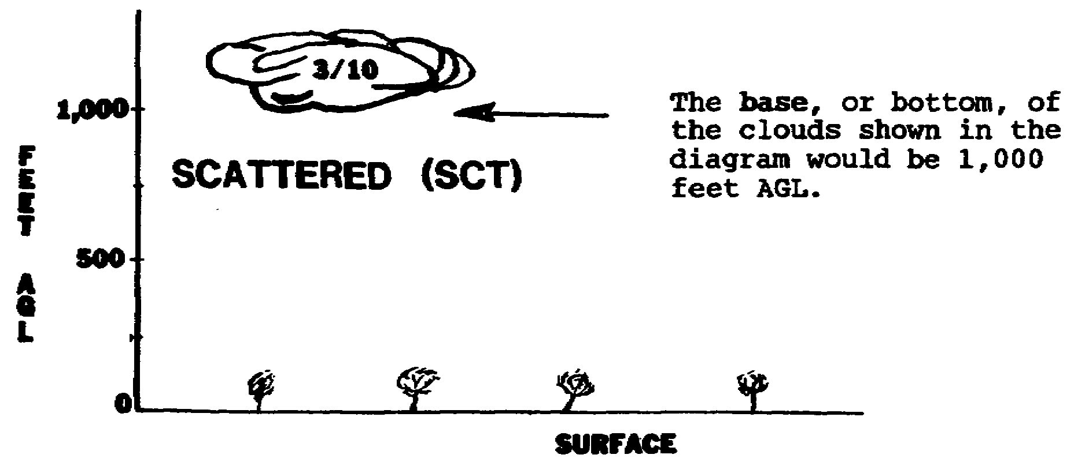

*********************************************************************
ANSWER 60

1. NGU = 1007.8; NZW = 1009.8

---------------------------------------------------------------------
FRAME 61

2. What is the ceiling, visibility, and sea level pressure at the location below?

CEILING VISIBILITY PRESSURE

_________________ __________ ________

VAD SA 1353 M12 BKN 4K 997/52/41/36Ø5/935

37 AV0603

ANSWER 39

BED = measured
DOV = indefinite
LIZ = measured
RME = estimated
---------------------------------------------------------------------
FRAME 40

In the airways code aviation weather report below, underline the sky condition segment that makes up the ceiling at each location.

23Ø6
SAUM8 KAWN 2623ØØ

ANB SA 2252 2Ø0SCT E5Ø OVC
BFM SA 2253 E9 BKN
BHM RS 2247 25 SCT E5Ø BKN
BNA SA 2253 9Ø E25Ø OVC
CHA SA 2248 7 SCT M23 BKN

*********************************************************************
ANSWER 82

VPS
---------------------------------------------------------------------
FRAME 83

What is the ceiling, visibility, and altimeter setting?

CEILING VISIBILITY ALTIMETER SETTING

_____________________ __________ _________________

CBM SA Ø249 -X 8 -BKN E25 OVC 2L-F 132/52/47/33Ø5/992/LB47 F3

38 AV0603

ANSWER 18

scattered.
---------------------------------------------------------------------
FRAME 19

If the coverage of two or more groups of clouds at the same altitude is hiding 1/10th through 5/10th of the sky, it would be reported in an airways code aviation weather report as a _______________layer.

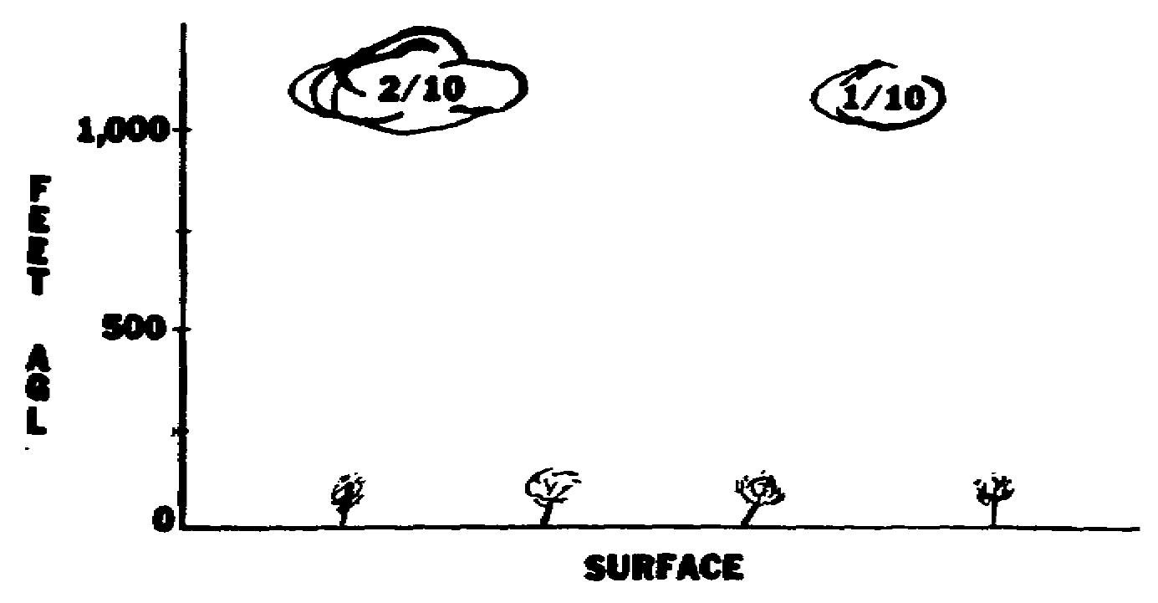

*********************************************************************
ANSWER 61

2. 1200 broken, 4 miles, 999.7 mb
---------------------------------------------------------------------
SURFACE TEMPERATURE AND DEW POINT FRAME 62

The next figures in the report are the surface temperature and dew point. Both are reported in degrees Fahrenheit (°F) and are separated by a slant line (/).

In the following report, the temperature is ____________, and the dew point is ____________.

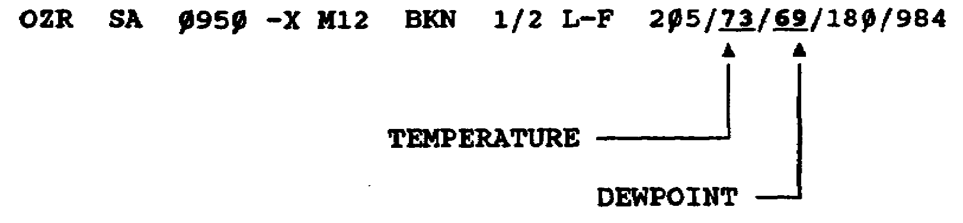

39 AV0603

ANSWER 40

BHM = E5Ø BKN
BNA = E25Ø OVC
CHA = M23 BKN
---------------------------------------------------------------------
REVIEW FRAME 41

1. A ceiling is the lowest sky condition reported as_____________, _____________, or ______________and is not classified as __________or _____________.

2. The ceiling height is preceded by a letter that is called a _______________________.

*********************************************************************
ANSWER 83

estimated 2,500 overcast; 2 miles; 29.92" Hg
---------------------------------------------------------------------
FRAME 84

OZR SA 1551 -X 4 -BKN M8 OVC 3K 132/66/52/ØØØØ/992/K4
SEM SA 1554 W3 X 3/4 K 2Ø2/63/51/18Ø5/Ø12
VPS SA 1547 5 SCT M1Ø BKN 3 226/55/49/19Ø9/Ø16/LB27
CBM SA 1549 5 -OVC 2R 146/25/17/3612/995/RB15

____________is reporting a ceiling of less than 500 feet, and
____________is reporting a visibility of less than 2 miles.

40 AV0603

ANSWER 19

scattered
---------------------------------------------------------------------
FRAME 20

If a coverage of two or more layers of clouds is hiding 1/10 through 5/10th of the sky, it would be reported in an airways code aviation weather report as ___________ scattered layers.

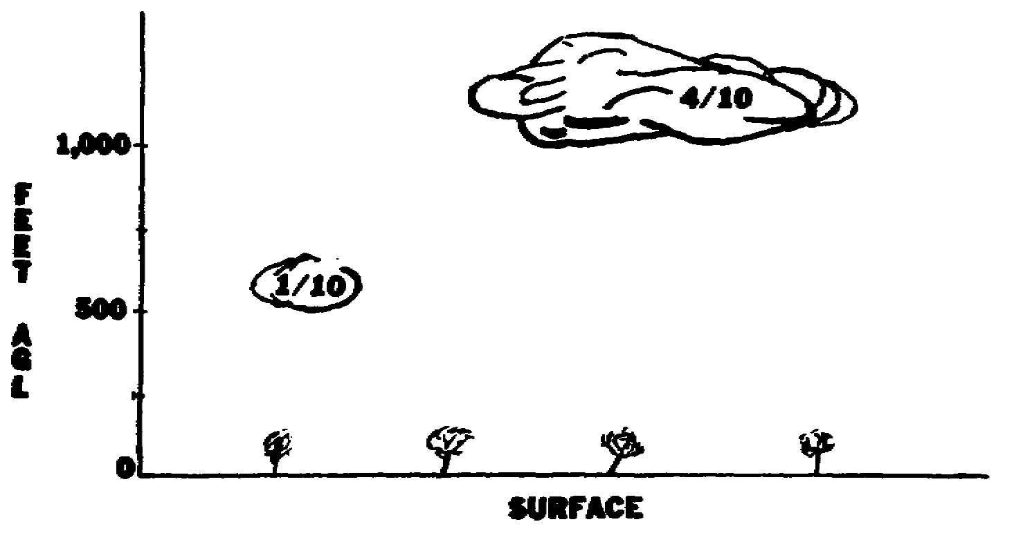

*********************************************************************
ANSWER 62

73ºF, 69ºF
---------------------------------------------------------------------
FRAME 63

If the temperature is plus 82ºF and the dew point is plus 61°F, they would appear on the report as 82/61.

If the temperature is minus 15ºF and the dew point is minus 20ºF, they would be reported as -15/-20.

41 AV0603

ANSWER 41

1. broken, overcast, obscured, thin, partial
2. ceiling designator.
---------------------------------------------------------------------
FRAME 42

3. Which location below is reporting an estimated ceiling of 30,000 feet overcast? ________________

4. Circle the location that is not reporting a ceiling?

1711
SAUE8 KAWN 1217ØØØ

ABY SA 165Ø 25 -BKN
AGS SA 1651 E3ØØ OVC
AHN SA 1654 M15Ø OVC
AMG SA 1646 15 SCT E15Ø OVC
ATL SA 1651 25 SCT M25Ø OVC
CEW SA 1652 25 -BKN M25Ø OVC

*********************************************************************
ANSWER 84

SEM (indefinite 300 obscured), SEM (3/4 mile)
---------------------------------------------------------------------
FRAME 85

Circle the location below that is reporting snow.

CBM SA Ø548 M12 OVC 3L 132/34/23/36Ø7/992/LB24
OZR SA Ø553 M12 OVC 4R 132/23/18/36Ø7/992
VPS SA Ø551 M12 OVC 3S 132/19/17/28Ø5/962/SB24

42 AV0603

ANSWER 20

two
---------------------------------------------------------------------
FRAME 21

The third sky condition abbreviation is BKN. This abbreviation is used to report one or more layers of clouds that are hiding 6/10th through 9/10th of the sky.

This symbol is read as _____________.

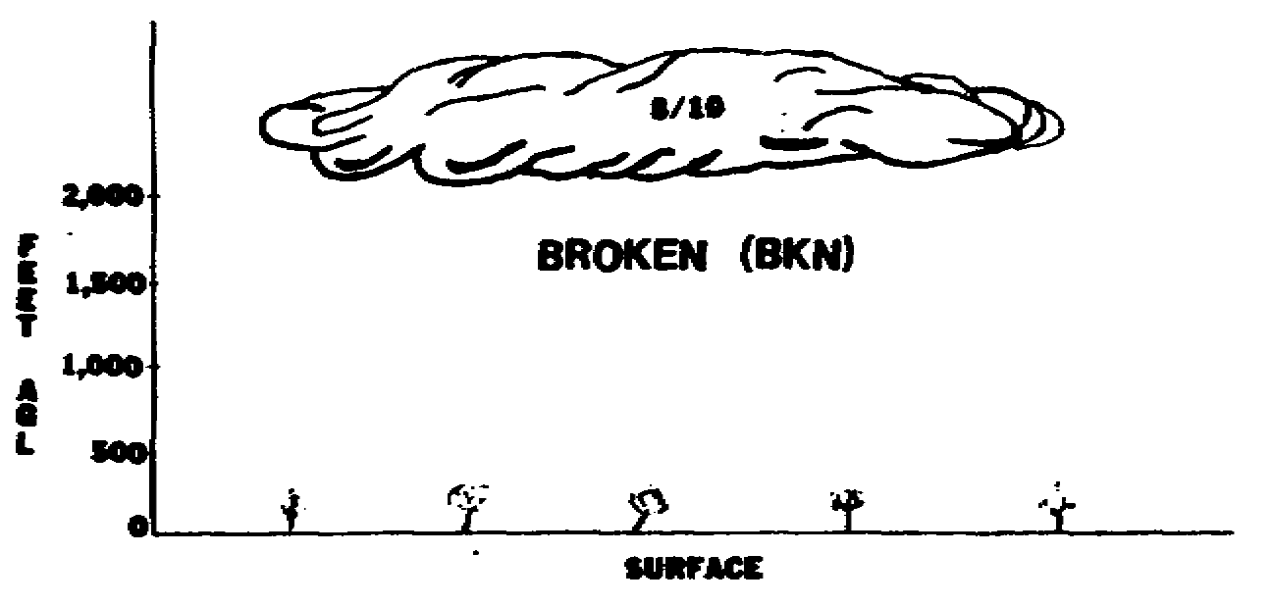

*********************************************************************
ANSWER 63

No response required.
---------------------------------------------------------------------
WIND DIRECTION AND SPEED FRAME 64

Normally, surface wind is reported using four numbers. The first two show the wind direction, and the second two show the wind speed. If the wind is from 340 degrees, it is reported as 34. If the wind is blowing at 10 knots, it is reported as 10. If the wind is blowing from 180 degrees at 8 knots, it will be reported as 18Ø8.

In the report below, the wind direction is from __________degrees, and the wind speed is________ knots.

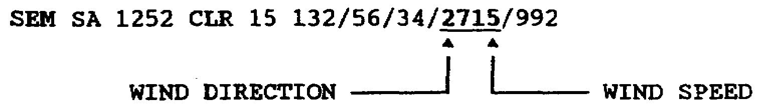

43 AV0603

ANSWER 42

3. AGS
4. ABY
---------------------------------------------------------------------
FRAME 43

5. Which location is reporting a ceiling of 25,000 feet? _________

Ø513
SAUM8 KAWN Ø9Ø5ØØ

CBM SA Ø449 -X M25 OVC 3R-
LSF RS Ø448 E25Ø OVC 15
OZR SA Ø452 8 SCT 25 -BKN M28 OVC 7
VPS SA Ø451 25Ø -BKN 1Ø

*********************************************************************
ANSWER 85

VPS
---------------------------------------------------------------------
FRAME 86
Explain the remarks below.

CBM SA Ø748 E25 BKN 8 132/75/64/1815G25/992/PIREP LGT TO MDT CAT
18Ø T-37

44 AV0603

ANSWER 21

broken.
---------------------------------------------------------------------
FRAME 22

When the sky is hidden by over 9/10th cloud coverage, it is reported with the abbreviation OVC and is read as______________________.

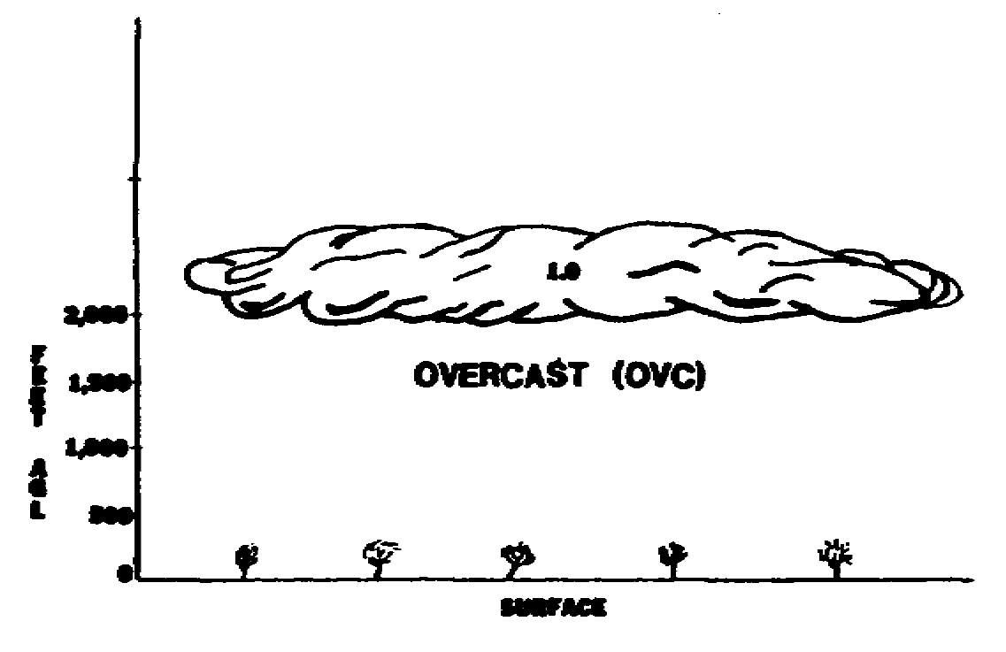
********************************************************************
ANSWER 64

270, 15
---------------------------------------------------------------------
FRAME 65

The wind direction is reported to the nearest 10 degrees, and wind speed is reported to the nearest knot. However, if the wind is calm (no wind), it is reported by the entry_________________.

NOTE: When any part of the wind report is estimated (direction,
speed, peak speed in gusts or squalls), the letter "E" precedes
the wind group.

LSF SA 1948 25 SCT M35 OVC 8 132/75/52/ØØØØ/992

CALM WIND

45 AV0603

ANSWER 43

5. LSF
---------------------------------------------------------------------

RETURN TO PAGE 3 FOR FRAME 44. CONTINUE WITH FRAMES AT THE
TOP OF THE RIGHT-HAND (ODD-NUMBERED) PAGES.

*********************************************************************
ANSWER 86

Pilot reports light to moderate clear air turbulence at 18,000 feet. Pilot is flying a T-37 aircraft.

---------------------------------------------------------------------

IF YOU THOROUGHLY UNDERSTAND AIRWAYS CODE AVIATION WEATHER REPORTS, CONTINUE WITH THE PRACTICE EXERCISE ON PAGE 49.

IF YOU DO NOT UNDERSTAND THE AIRWAYS CODE AVIATION WEATHER REPORT, RETURN TO FRAME 1 ON PAGE 3 AND REWORK THE PT.

46 AV0603

ANSWER 22

overcast.
---------------------------------------------------------------------

TURN TO PAGE 4 FOR FRAME 23. CONTINUE WITH THE FRAMES AT THE TOP OF THE LEFT-HAND (EVEN-NUMBERED) PAGES.

*********************************************************************
ANSWER 65

ØØØØ
---------------------------------------------------------------------

RETURN TO PAGE 4 FOR FRAME 66. CONTINUE WITH THE FRAMES AT
THE BOTTOM OF THE LEFT-HAND (EVEN-NUMBERED) PAGES.

47 AV0603

LESSON 1

PRACTICE EXERCISE

The following items will test your grasp of the lesson material. Each item has only one correct answer. When you complete the exercise, check your answers with the answer key that follows. If you answer any item incorrectly, restudy that part of the lesson.

REQUIREMENT: Solve 1 through 3 by selecting the correct answers.

1. In airways code aviation weather reports, cloud bases are given in hundreds of

A. meters above sea level (ASL).
B. meters AGL.
C. feet AGL.
D. feet ASL.

2. Which symbol indicates a total obscuration of the sky that is caused by a surface-based phenomena?

A. E
B. M
C. X
D. -X

3. The three sky conditions that constitute a ceiling are broken,

A. overcast, or obscured.
B. scattered, or obscured.
C. scattered, or overcast.
D. scattered, overcast, or obscured.

REQUIREMENT: Solve 4 through 13 by using the following report:

1515
SAUM5 KAWN 1515ØØ

ATL SA 1451 E12 OVC 3ZR 1Ø8/26/17/32Ø7/986/ZRB32
JAX SA 1453 CLR 15 181/5Ø/4Ø/1815G23/ØØ9
LDX SA 1448 CLR 1Ø 995/77/5Ø/18Ø5/942
MCN SA 1446 W3 X 1/16 L-F 14Ø/41/39/13Ø6/996/LB45
MIA SA 145Ø 18 SCT 85 -BKN M12Ø OVC 12 151/86/51/
ØØØØ/ØØ1
TPA SA 1447 WØ X 1/2 F 132/72/72/24Ø5/992

49 AV0603

4. At what station is the temperature 26 degrees and the dew point 17 degrees?

A. ATL
B. JAX
C. MCN
D. TPA

5. What was the actual time of observation at ATL?

A. 1446
B. 1451
C. 1500
D. 1515

6. Which location is reporting a visibility of 1/16th of a statute mile?

A. JAX
B. MCN
C. MIA
D. TPA

7. What is the ceiling at MIA?

A. 1800 scattered
B. 8500 light broken
C. measured 1200 overcast
D. measured 12,000 overcast

8. Which location has an altimeter setting of 29.92" Hg?

A. ATL
B. LDX
C. MCN
D. TPA

9. What is the vertical visibility at MCN?

A. 30 feet
B. 300 feet
C. 30 meters
D. 300 meters

10. Which location is reporting the lowest ceiling?

A. ATL
B. MCN
C. MIA
D. TPA

50 AV0603

11. What is the sea level pressure at MIA?

A. 9151
B. 915.1
C. 10151
D. 1015.1

12. Which location is reporting the highest altimeter setting?

A. ATL
B. JAX
C. MCN
D. MIA

13. From what direction, in degrees, is the wind at JAX?

A. 040
B. 050
C. 180
D. 181

REQUIREMENT: Solve 14 through 16 by referring to the report below.

SAUM5 KAWN Ø2Ø9ØØ

ELD SA Ø85Ø 8 -BKN 18 OVC 5R 1ØØ/37/31/2712/983/RB45
MGM SA Ø848 15 SCT M25Ø OVC 15 146/83/62/18Ø9/996
SHV RS Ø852 M25 OVC 3T+RW+ 171/75/63/1815/ØØ4/RWB15
TXK SA Ø846 -X M15 OVC 1/2 S-F 132/22/19/35Ø8/992/SB25
F3

14. Which station is reporting snow?

A. ELD
B. MGM
C. SHV
D. TXK

15. What time did rain begin at ELD?

A. 0145Z
B. 0245Z
C. 0845Z
D. 0945Z

51 AV0603

16. Which station is reporting a temperature of 75 and an altimeter setting of 30.04?

A. ELD
B. MGM
C. SHV
D. TXK

REQUIREMENT: Solve 17 through 20 by using the report directly below each exercise.

17. What time did rain begin at Maxwell AFB (MXF)?

SAUM7 KAWN 1218ØØ

MXF SA 1752 M25 BKN 4Ø OVC 4RW- 1ØØ/72/5Ø/2312/983/RB35

A. 1735Z
B. 1835Z
C. 1735 local
D. 1835 local

18. What is the sky condition and visibility at Moody AFB (VAD)?

VAD SA 1454 32 SCT 8 171/79/57/251Ø/ØØ4/CLDS LWR SW

A. unlimited with 8 statute miles
B. 3200 broken with 8 nautical miles
C. 3200 scattered with 8 statute miles
D. 3200 scattered with 8 nautical miles

19. What is the sky condition at Cairns AAF (OZR) ?

OZR SA 12Ø1 15 SCT 1Ø 146/81/75/2115/996/SCTD LYR INCRG

A. unlimited
B. 1500 broken
C. 1500 overcast
D. 1500 scattered

20. What is the type of precipitation, obstruction to vision, and visibility at Langley Field (LFI)?

LFI SA Ø9ØØ M4 OVC 1/2 L-F 166/68/65/15Ø6/ØØ4/LB37

A. light drizzle, fog, and 1/2 mile
B. drizzle, very light fog, and 1/2 mile
C. light drizzle, light fog, and 1/2 mile
D. drizzle and fog reducing the visibility from 2 miles to 1 mile.

52 AV0603

LESSON 2

PRACTICE EXERCISE

ANSWER KEY AND FEEDBACK

Item Correct Answer and Feedback

1. C. feet AGL

Cloud bases are given in hundreds of feet AGL. (pages 4 and 6, Frames 23 and 24)

2. C. X

A total obscuration is shown by an X (10/10ths of the sky is obscured). (pages 16 and 18, Frames 29 and 30)

3. A. overcast, or obscured.

A ceiling is the lowest sky condition reported as broken, overcast, or obscured. (page 30, Frame 36)

4. A. ATL

ATL is the only station reporting a temperature of 26 degrees and a dew point of 17 degrees. (page 39, Frame 62)

5. B. 1451

The actual time of observation follows the type of report. (pages 9 and 25, Frames 4 and 12)

6. B. MCN

When the visibility is less than 3 miles, fractions will be reported. (pages 3 and 5, Frames 44 and 45)

7. D. measured 12,000 overcast

A ceiling will have a ceiling designator and the lowest sky condition reported as broken, overcast, or obscured. (pages 30, 34, and 36; Frames 36, 38, and 39)

53 AV0603

Item Correct Answer and Feedback

8. D. TPA

When the altimeter setting is reported as 992, place a decimal two points to the left and add a numeral 2 to the front. (pages 10 and 12, Frames 69 and 70)

9. B. 300 feet

Since the sky is completely obscured and the base of obscuration is at 300 feet, vertical visibility is 300 feet. (page 20, Frame 31)

10. D. TPA

A ceiling will have a ceiling designator and the lowest sky condition reported as broken, overcast, or obscured. (pages 30, 34, and 36; Frames 36, 38, and 39)

11. D. 1015.1

Since the sea level pressure is reported as 151, place a decimal one point to the left and add the numeral 10 to the front. (pages 31 and 33, Frames 58 and 59)

12. B. JAX

JAX is the only station reporting the highest altimeter setting--30.09" Hg. (pages 10 and 12, Frames 69 and 70)

13. C. 180

The wind direction is reported as 18; therefore, you will add a zero at the end. (page 43, Frame 64)

14. D. TXK

Weather follows visibility; therefore, weather is reported as light snow (S-). (pages 15 and 92, Frame 50 and Exhibit 5)

15. C. 0845Z

ELD indicates rain began falling 45 minutes past the previous hour (RB45) or that rain began at 0845Z. (page 30, Frame 79)

54 AV0603

Item Correct Answer and Feedback

16. C. SHV

SHV is the only station reporting a temperature of 75 degrees and the altimeter setting is reported as 004. Therefore, place a decimal two points to the left and add a numeral 3 to the front. (pages 10 and 39, Frames 62 and 69)

17. A. 1735Z

The report indicates that rain began falling 35 minutes past the previous hour (RB35) or rain began at 1735Z. (pages 18 and 20, Frames 73 and 74)

18. C. 3200 scattered with 8 statute miles

The sky condition is reported in hundreds of feet AGL; SCT means scattered; and visibility is reported in statute miles. (pages 3, 5, and 6; Frames 24, 44, and 45)

19. D. 1500 scattered

The sky co ndition is reported in hundreds of feet AGL and SCT means scattered. (page 6, Frame 24)

20. A. light drizzle, fog, and 1/2 mile

Weather is reported as light drizzle (L-); obstruction to vision is reported as fog (F); and visibility is reported less than 3 miles, fractions included. (pages 3, 5, 15, and 19; Frames 44, 45, 50, and 52)

55 AV0603

LESSON 2

METAR CODE AVIATION WEATHER REPORT

Critical Task: 011-144-0010

OVERVIEW

LESSON DESCRIPTION:

In this lesson you will learn to decode the METAR code aviation weather report to include location identifier, time, wind data, prevailing visibility, runway visual range (RVR) local, significant weather, sky condition, temperature data, altimeter setting, ceiling height, weather symbols, and standardized contractions of words in the remarks section.

TERMINAL LEARNING OBJECTIVE:

ACTION: Interpret a METAR code aviation weather report.

CONDITION: You will use the lesson text to complete the action.

STANDARD: You will decode each item of information on a METAR code aviation weather report.

REFERENCE: The material in this lesson was derived from the following publications: DOD FLIP, GP; FAA Order 7350.5; FM 1-230; International Civil Aviation Organization (ICAO) Document 7910.

SAFETY CONSIDERATIONS: none

TRAINING RISK ASSESSMENT CODE: L

ENVIRONMENTAL CONSIDERATIONS: none

INTRODUCTION

Aviation circuits collect and relay weather condition information hourly for reporting stations outside continental North America, Guam, Hawaii, and Puerto Rico. This information is a METAR. In your duties as an aviation operations specialist, you may see METAR code aviation weather reports on a daily basis. Therefore, you must understand and be able to interpret (explain) the information found in the collective report.

57 AV0603

THIS LESSON CONTAINS A 28-FRAME PROGRAMMED TEXT (PT). THIS PT WILL HELP YOU UNDERSTAND THE DIFFERENT PORTIONS OF THE METAR.

WRITE OR CIRCLE THE ANSWER TO EACH QUESTION WITHIN EACH FRAME, AND CHECK YOUR ANSWER WITH THE SOLUTION, AT THE TOP OF THE NEXT FRAME. BEGIN WITH FRAME 1 ON PAGE 59 AND CONTINUE WITH THE FRAMES AT THE TOP OF THE RIGHT-HAND (ODD-NUMBERED) PAGES UNTIL GIVEN FURTHER INSTRUCTIONS.

58 AV0603

GENERAL INFORMATION FRAME 1

Observers assemble and report weather information hourly throughout the world. When transmitted (sent) within the United States or its territories, this information is referred to as the airways code aviation weather report as discussed in Lesson One.

A similar report used in overseas locations is compiled and transmitted by Air Weather Service units of the USAF and internationally is called a meteorological terminal aviation report (METAR) code.

The airways code aviation weather report and METAR code formats
are similar and provide aviation personnel with the most up-to-
date______________ information.

NOTE: The word "METAR" and the time are not normally included
for each station in a collective. It will normally be part of
the heading.

*********************************************************************
CLOUD GROUP FRAME 15

The next grouping is the cloud group. It is reported in one or more sets of six figures. The six-figure set includes one number followed by two letters, and then by three numbers. Look at the two examples below.

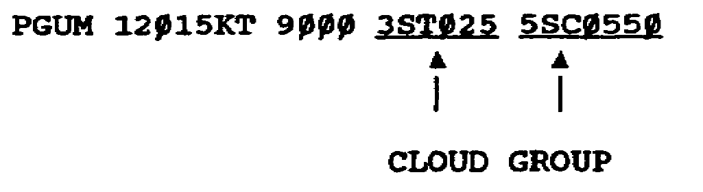

The first number in the cloud group gives the number in eighths of cloud coverage at that height. Thus, 3STØ25 means three-eighths coverage and 5SCØ5Ø indicates _____________coverage.

59 AV0603

FRAME 8

A maximum wind is reported when it exceeds the average wind by 5 knots or more.

EXAMPLE: 18Ø12/35KT indicates the wind is from 180 degrees at 12 knots, with a maximum of 35 knots.

In the report below, the wind direction is from____________ degrees, the average wind speed is_____________ knots, and the maximum wind speed is___________ knots.

RPMS 18Ø15/3ØKT

*********************************************************************
FRAME 22

A partial obscuration is indicated by a number representing the amount of the sky that is obscured in fractions of eighths. This is followed by the abbreviation for the obscuration and then three slant lines (///). Therefore, 5FG/// indicates that five-eighths of the sky is obscured by fog with no vertical visibility being reported.

NOTE: Vertical visibility is only reported when there is a total obscuration.

In the following report, there is a partial obscuration covering ___________________________of the sky, and the obscuration is being caused by__________________.

PHIK 1ØØØ5KT Ø3ØØ 55XXDZ 6DZ///

60 AV0603

ANSWER 1

weather
*********************************************************************
FRAME 2

STUDY: Exhibit 10

The key in Exhibit 10 is similar to the one used in the standard aviation weather report and breaks down the information contained in an METAR.

*********************************************************************
ANSWER 15

five-eighths
---------------------------------------------------------------------
FRAME 16

STUDY: Exhibit 13

You should familiarize yourself with the various cloud symbols and be able to recall the name for each abbreviation. This will assist you when interpreting the METAR.

Immediately following the "eighths" coverage are two letters. These letters represent the cloud type in that cloud layer. Thus, 3STØ25 means that three-eighths of the sky is covered by stratus clouds.

In the report below,_______________ clouds are being reported.

PHIK Ø7Ø12KT 7ØØØ 2CUØ18 4CUØ35

61 AV0603

ANSWER 8

180, 15, 30
---------------------------------------------------------------------
FRAME 9

A variable wind is reported as VRB.

EXAMPLE: VRBØ5KT indicates the wind direction is variable and the wind speed is 5 knots.

The wind direction below is_______________ , and the wind speed is __________knots.

PGUM VRBØ4KT

*********************************************************************
ANSWER 22

six-eighths, drizzle.
---------------------------------------------------------------------
FRAME 23

When the conditions listed below exist simultaneously, the code word that means ceiling and visibility OK (CAVOK) is used in place of visibility, RVR, present weather, and cloud group data.

NOTE: CAVOK is not used at USAF locations.

Visibility is 10 kilometers (10,000 meters) or more (roughly 6 miles).

► No clouds reported below 5,000 feet.

► No precipitation or thunderstorms.

62 AV0603

ANSWER 2

No response required.
---------------------------------------------------------------------
LOCATION IDENTIFIER FRAME 3

The heading of a METAR is much the same as the heading of the airways aviation weather report and is not addressed in this lesson. The first entry in the body of the METAR is a four-letter group called the____________________ ________________________.

PHIK Ø7Ø12KT 7ØØØ 2CUØ18 4CUØ35 32/19 2974INS
PGUA VRBØ5KT 9999 1Ø/Ø5 2998INS FU LYR SE
PGUM Ø1ØØ6KT Ø6ØØ RØ7ØØ 47FG 9FGØØ3 12/11 2995INS CIGØØ3

LOCATION IDENTIFIER

The first letter gives the portion of the world in which the reporting station is located. The last three letters represent the normal identifiers used in aviation weather reports.

NOTE: The time of the observation is located before the wind data in a METAR.

*********************************************************************
ANSWER 16

cumulus
---------------------------------------------------------------------
FRAME 17

The last three numbers in the cloud group give the cloud height AGL and represent the base of the clouds in hundreds of feet. (As in earlier examples of reporting the base of cloud heights, the last two digits are dropped off.)

63 AV0603

ANSWER 9

variable, 4
---------------------------------------------------------------------
VISIBILITY FRAME 10

Following the wind data in the report is visibility. Visibility is reported in meters in the following increments:

VISIBILITY LESS THAN 5,000 METERS-NEAREST 100 METERS
VISIBILITY 5,000 TO 9,000 METERS-NEAREST 1,000 METERS
VISIBILITY 10,000 METERS OR MORE-REPORTED AS 9999 ON THE METAR

In the following report, Hickham Air Force Base (AFB), Hawaii (HIK), is reporting a visibility of___________ meters.

PHIK Ø7Ø12KT 7ØØØ

*********************************************************************
ANSWER 23

No response required.
---------------------------------------------------------------------
TEMPERATURE AND DEW POINT FRAME 24

Following the cloud group entry is the temperature and the dew point reported in degrees Celsius (°C) and separated by a slant line. The letter "M" preceding the figures indicates that the temperature or dew point was below zero.

In the following report, the temperature is______º C, and the dew point is °C.

PHIK Ø7Ø12KT 7ØØØ 2CUØ18 4CUØ35 32/19

64 AV0603

ANSWER 3

location identifier.
---------------------------------------------------------------------
FRAME 4

(Refer to Exhibit 11.) The METAR stations in the report below are located in the______________.

PGUA 12Ø15KT 9ØØØ 3STØ25 5SCØ5Ø 15/1Ø 3ØØ5INS CIGØ5Ø
PGUM Ø1ØØ6KT Ø6ØØ R07ØØ 47FG 9FGØØ3 12/11 2995INS CIGØØ3

*********************************************************************
ANSWER 17

No response required.
---------------------------------------------------------------------
FRAME 18

Complete the following information for the reports below:

EIGHTHS CLOUD TYPE HEIGHT

RODN = __________ _________________ ____________

RPMB = __________ _________________ ____________

RODN 25Ø25KT Ø8ØØ RØ9ØØ 98TSSA 8CBØ15
RPMB 18Ø15KT 9ØØØ 6CI3ØØ

65 AV0603

ANSWER 10

7,000
---------------------------------------------------------------------
RUNWAY VISUAL RANGE FRAME 11

The RVR is the horizontal distance an aviator sees down the active runway from the approach end. In an METAR, the RVR, when reported, is preceded by the letter "R". Thus, RØ5ØØ indicates that the RVR is 500 meters.

In the report given below, the RVR is___________ meters.

PGUM Ø1ØØ6KT Ø6ØØ RØ7ØØ

*********************************************************************
ANSWER 24

32, 19
---------------------------------------------------------------------
ALTIMETER SETTING FRAME 25

The altimeter setting is reported in inches of mercury along with the units. Unlike the airways code aviation weather report, the altimeter setting is also reported in the full four-digit figure on the METAR.

Referring to the report below, what is the altimeter setting being reported? _______________________

RODN 25Ø25KT Ø8ØØ RØ9ØØ 98TSSA 8CBØ15 28/21 2984INS CIGØ15

66 AV0603

ANSWER 4

Pacific (including Alaska)
---------------------------------------------------------------------
WIND DIRECTION AND SPEED FRAME 5

After the time of transmission, you find a group of five numbers
that give information about the________________________________ and ______________.

RODN 18Ø15KT
RPMB 25Ø25KT

*********************************************************************
ANSWER 18

RODN = eight, cumulonimbus, 1,500 feet
RPMB = six, cirrus, 30,000 feet
---------------------------------------------------------------------
FRAME 19

Decode the report below.

Wind = ______________________________________________________________

Visibility = ________________________________________________________

RVR = _______________________________________________________________

Present Weather = ___________________________________________________

Clouds = ____________________________________________________________

PGUM VRBØ5KT Ø5ØØ RØ6ØØ 47FG 2CUØ18 4CUØ6Ø

67 AV0603

ANSWER 11

700
---------------------------------------------------------------------
PRESENT WEATHER FRAME 12

So far you have learned that the METAR contains the location identifier, the wind direction and speed, the visibility, and the RVR. The RVR is not always reported. (RVR is reported normally when visibility is less than 1 mile or RVR is less than 6,000 feet.)

The next entry in the METAR is for present weather conditions. (Refer to Exhibit 12.) Present and past weather is reported in a code of numbers and letters. The letters provide a general description of the weather while the numbers permit a more detailed description of the weather conditions.

LICZ 18Ø15KT Ø4ØØ RØ5ØØ 6ØRA

*********************************************************************
ANSWER 25

29.84 inches of mercury
---------------------------------------------------------------------
CEILING FRAME 26

After the altimeter setting, the ceiling height is reported on the METAR. The abbreviation "CIG" is followed by the numerical value used to indicate the height of the ceiling.

In the report below, station RONA is reporting a ceiling of _____ feet.

RONA 25Ø25KT Ø8ØØ RØ9ØØ 98TSSA 8CBØ15 28/21 2964INS CIGØ15

68 AV0603

ANSWER 5

wind direction, speed
---------------------------------------------------------------------
FRAME 6

The first three figures represent the wind direction, and the last two represent the wind speed. Thus, 18Ø15KT means the wind is from 180 degrees at 15 knots.

The wind in the following report is from__________ degrees, and the wind speed is________ knots.

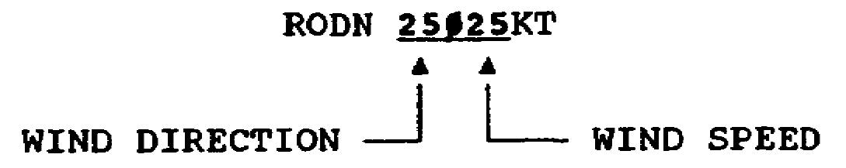

*********************************************************************
ANSWER 19

Wind = variable at 5 knots
Visibility = 500 meters
RVR = 600 meters
Present Weather = fog
Cloud = two-eighths cumulus at 1,800 feet
= four-eighths cumulus at 6,000 feet
---------------------------------------------------------------------
FRAME 20

A total obscuration is indicated by the code number 9 followed by the abbreviation of the present weather causing the obscuration. This is followed by the vertical visibility.

Vertical visibility is coded just the same as the cloud base is. Thus, a total obscuration with a vertical visibility of 500 feet is reported as 9FGØØ5. (Total obscuration caused by fog.)

69 AV0603

ANSWER 12

No response required.
---------------------------------------------------------------------
REVIEW FRAME 13

1. (Use Exhibit 12.) The entry 56FZDZ indicates that the present weather is_______________________.

*********************************************************************
ANSWER 26

1,500
---------------------------------------------------------------------
REMARKS FRAME 27

The last section of the METAR is the remarks section. The remarks provide the aviator with detailed information for flight planning purposes and are either abbreviated or in plain language. They are much the same as the remarks used in the aviation weather reports (Exhibit 9), and you will probably be able to recognize most entries appearing in the METAR.

70 AV0603

ANSWER 6

250, 25
---------------------------------------------------------------------
FRAME 7

Wind direction is reported to the nearest 10 degrees with reference to true north, and wind speed is reported to the nearest knot. However, if the wind is calm (no wind), it is reported as__________.

EGLL ØØØØØKT

CALM WIND

*********************************************************************
ANSWER 20

No response required.
---------------------------------------------------------------------
FRAME 21

(Refer to Exhibit 12.) In the following report, there is a total obscuration caused by__________ that is restricting the vertical visibility to_________ feet.

PGUM Ø1ØØ6KT Ø6ØØ RØ7ØØ 39BLSN 9SNØØ5

71 AV0603

ANSWER 13

1. light freezing drizzle
---------------------------------------------------------------------
FRAME 14

2. (Use Exhibit 12.) What type precipitation is being reported by the following stations?

ROPN = ______________________________________________________________

MUGM = ______________________________________________________________

RONA = ______________________________________________________________

ROPN 25Ø25KT Ø8ØØ 98TSSA
MUGM 27Ø3ØKT 1ØØØ 25RESH
RONA Ø9ØØ2KT Ø7ØØ 64XXRA

*********************************************************************
ANSWER 27

No response required.
---------------------------------------------------------------------
FRAME 28

Some remarks symbols used in METARs and aviation weather reports are not the same.

EXAMPLE: In the METAR, FU is the symbol used for smoke; in the airways aviation weather report, K is the symbol used for smoke.

ADDITIONAL REMARKS MEANING

VIS S 9ØØØ Visibility to the south is 9,000 meters
CIG RGD Ceiling ragged
FROPA 16ØØ Frontal passage 16ØØZ
CU VCNTY Cumulus clouds in vicinity
CIGNO No ceiling
FU LYR NE Smoke layer northeast
BLU Blue sky can be seen
WHT White sky can be seen

72 AV0603

ANSWER 7

ØØØØØ
---------------------------------------------------------------------

RETURN TO PAGE 60 FOR FRAME 8. CONTINUE WITH FRAMES AT THE TOP OF THE LEFT-HAND (EVEN-NUMBERED) PAGES.

*********************************************************************
ANSWER 21

snow, 500
---------------------------------------------------------------------

RETURN TO PAGE 60 FOR FRAME 22. CONTINUE WITH FRAMES AT THE TOP OF THE LEFT-HAND (EVEN-NUMBERED) PAGES.

73 AV0603

ANSWER 14

2. ROPN = thunderstorm with dust or sand storms
MUGM = recent showers
RONA = heavy rain

---------------------------------------------------------------------

RETURN TO PAGE 59 FOR FRAME 15. CONTINUE WITH FRAMES AT THE TOP OF THE RIGHT-HAND (ODD-NUMBERED) PAGES.

*********************************************************************
ANSWER 28

No response required.
---------------------------------------------------------------------

IF YOU THOROUGHLY UNDERSTAND METARS, CONTINUE WITH THE PRACTICE EXERCISE ON PAGE 75.

IF YOU DO NOT UNDERSTAND THE METAR, RETURN TO FRAME 1 ON PAGE 59 AND REWORK THE PT.

74 AV0603

LESSON TWO

PRACTICE EXERCISE

The following items will test your grasp of the lesson material. Each item has only one correct answer. When you complete the exercise, check your answers with the answer key that follows. If you answer any item incorrectly, restudy that part of the lesson.

1. Decode the following METAR:

PHIK Ø7Ø12KT 11ØØ R15ØØ 51DZ 2NSØ3Ø 5AS18Ø 7CS3ØØ 27/26
2992INS CIG18Ø VIS S 3ØØØ

a. Wind _________________________at _______________

b. Visibility _______________________

c. RVR ________________

d. Present weather ____________________

e. Cloud layers

(1) _______________,________________, _______________

(2) _______________,________________, _______________

(3) _______________,________________, _______________

f. Temperature __________, dew point________

g. Altimeter setting_________________________

h. Ceiling_______________________

i. Remarks_______________________

75 AV0603

2. Interpret the following METAR, and write it in plain language format.

PGUA VRBØ5KT Ø3ØØ RØ3ØØ 61RA 6NSØØ5 3Ø/29 2944INS CIGØØ5
FU LYR S

76 AV0603

LESSON TWO

PRACTICE EXERCISE

ANSWER KEY AND FEEDBACK

Item Correct Answer and Feedback

la 070 degrees, 12 knots

The wind direction is reported to the nearest 10 degrees; wind speed is reported to the nearest knot. (pages 67, 69, and 71; Frames 5, 6, and 7)

1b 1,100 meters

Visibility is reported in meters. (page 64, Frame 10)

1c 1,500 meters

The RVR is reported in meters. (page 66, Frame 11)

1d light drizzle

The present weather is reported in a code of numbers and letters. (page 68, Frame 12)

1e(l) two-eighths, nimbostratus, 3,000 feet
(2) five-eighths, altostratus 18,000 feet
(3) seven-eighths, cirrostratus, 30,000 feet

In the cloud group the first number indicates the amount of sky coverage, two letters indicate the cloud type, and three numbers give the cloud height in hundreds of feet AGL. (pages 59, 61, and 63; Frames 15, 16, and 17)

1f 27ºC, 26ºC

Temperature and dew point are reported in degrees Celsius. (page 64, Frame 24)

1g 29.92

The altimeter setting is reported in inches of mercury. Add the decimal two points to the left. (page 66, Frame 25)

77 AV0603

1h 18,000 feet

The ceiling is reported as CIG followed by the height in hundreds of feet AGL. (page 68, Frame 26)

1i visibility to the south is 3,000 meters

In the remarks section, visibility is reported in meters and the direction from the airfield. (pages 70 and 72, Frames 27 and 28)

2. Variable wind at 5 knots, visibility 300 meters; RVR 300 meters, present weather light rain, six-eighths nimbostratus at 500 feet, temperature 30°C, dew point 29ºC, altimeter setting 29.44 inches of mercury, ceiling 500 feet, smoke layer to the south.

According to FAA regulations this is the only answer. (pages 59, 61, 63, and 64, and 66 through 72; Frames 5 through 7, 10 through 12, 15 through 17, and 24 through 28

78 AV0603

